1. Amount of Data Rendered to Tableau
The dataset was successfully loaded into Tableau for analysis and visualization. The dataset contains 345,407 rows and 10 columns, with an approximate data size of 15 MB.
The complete dataset was rendered in Tableau, allowing the visualizations to be created and analyzed efficiently.
Dataset Details

Parameter | Data(value)
Total Row | 345,407
Total Columns | 10
Data Size | 15MB

Number of Columns and Rows in the Dataset
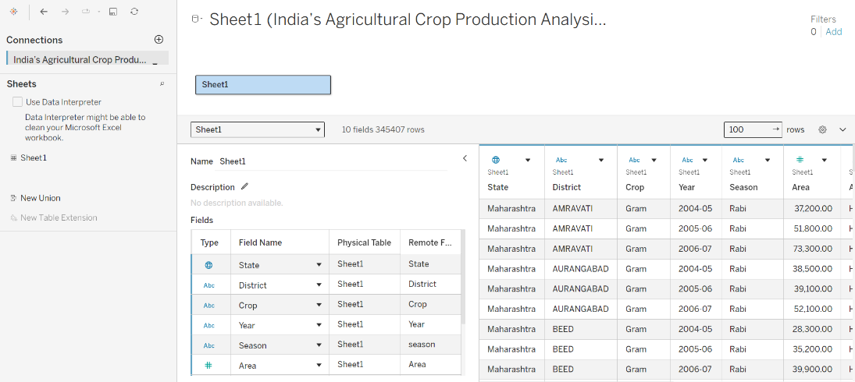
Dataset File Size
